 |  |  | 

Project Acronym | Fed4FIRE
Project Title | Federation for FIRE
Instrument | Large scale integrating project (IP)
Call identifier | FP7-ICT-2011-8
Project number | 318389
Project website | www.fed4fire.eu
Experiment | GEO-Cloud

Implementation of PL Experiment

Work package | WP10
Task | T10.1.2 GEO-Cloud Experiment
Due date | 09/05/2014
Submission date | 09/05/2014
Report Lead | Félix Pedrera (DEIMOS)
Version | 1.0
Authors | Manuel José Latorre, Félix Pedrera, Miguel Lizondo, César González, Esteban Bueno, Rubén Pérez (DEIMOS)
Reviewers | Jonathan Becedas (DEIMOS)

Document ID | GEO-Cloud-DMS-TEC-TEC12-E
Abstract | This document provides technical information about the implementation of the experiment in PlanetLab
Keywords | Report

Nature of the document | R | Report | X
Nature of the document | P | Prototype
Nature of the document | D | Demonstrator
Nature of the document | O | Other
Dissemination level | PU | Public
Dissemination level | PP | Restricted to other programme participants (including the Commission)
Dissemination level | RE | Restricted to a group specified by the consortium (including the Commision)
Dissemination level | CO | Confidential, only for members of the consortium (including the Commission) | X

Disclaimer

The information, documentation and figures available in this deliverable, is written by the Fed4FIRE (Federation for FIRE) – project consortium under EC co-financing contract FP7-ICT-318389 and does not necessarily reflect the views of the European Commission. The European Commission is not liable for any use that may be made of the information contained herein.
Executive Summary
In this document the implementation of the experiment in PlanetLab is described. This experiment has as objective the measurements of the network impairments to model a real network. These impairments will be implemented in the network that communicates the simulators implemed in Virtual Wall with the BonFIRE cloud.
Acronyms and Abbreviations

PL | PlanetLab
VM | Virtual Machine
VW | Virtual Wall
Table of Contents

1 Introduction 7
2 Platforms and Tools Description 8
3 PlanetLab experiment 9
3.1 System modeling 9
3.2 Network Design 11
3.3 Experiment Design 13
3.4 Experiment Execution 13
4 Conclusions 14
5 Bibliography 15

Introduction
The GEO-Cloud experiment is separated into two experiments: i) an experiment that represents a complete Earth Observation system, including the space system communicated with a cloud base data center for the ingestion, processing, storage and distribution of satellite imagery through high added value web services (Virtual Wall and BonFIRE are the testbeds used); ii) an experiment to measure and model the network that links the space system with the cloud as realistically as possible. The results of this experiment carried out in PlanetLab are used to link the simulators implemented in Virtual Wall with the cloud in BonFIRE to simulate a real network with realistic characteristics.

This document is devoted to explain the implementation of the experiment in PlanetLab. First, the motivation for the use of PlanetLab is explained together with the design of the real system. Then, the platform and tools used are described with their roles in the experiment. In addition, the network and experiment design are broadly discussed. The execution of the experiment is also presented. Finally, conclusions of this implementation are included.

Definitions

Effective bandwidth (Mbps) is the actual bandwidth at which the data can be transmitted on a link. The nominal bandwidth cannot be reached due to network congestion, the distance between nodes, delays, etc. Effective bandwidth is higher when nodes are closer, the congestion is scarce and the delays in the transmission are not long.
Bandwidth of the network(Mbps), which is the nominal “width” of the channel used, if the bandwidth increases, more data can simultaneously be sent, reducing the necessary time to transfer a packet of data. It is usually confused with the signal velocity, which affects the time the data takes to travel to the receiver (latency) but bandwidth cannot reduce this time.
Loss rate is the fraction of data lost in the communication with respect to all the data sent. It is a value between 0 and 1. It can also be provided in percentage.
Latency (ms) is the time it takes a signal to travel from its source, trough the communication channel, until it reaches the receiver. It is related with the distance between the nodes, the network congestion and the propagation velocity (a fraction of the light speed) among other parameters.

Platforms and Tools Description
The experiment presented in this report is completely carried out in PlanetLab, although the results obtained will be used to implement a realistic model of the networks in the communications between the simulators and the cloud system of the GEOCloud experiment implemented in Virtual Wall and BonFIRE respectively.
PlanetLab is a global research network that supports the development of new network services (Europe, 2014). This testbed currently consists of 1188 nodes at 582 sites, which allows researchers to develop new technologies for distributed storage, network mapping, peer-to-peer systems, distributed hash tables and query processing. Currently it is split into two platforms: PlanetLab Europe that contains the European nodes and PlanetLab Central which contains the nodes located outside Europe. For the experiment we use nodes from both of them.
To implement and execute the experiment we use the following tools:
- NEPI (INRIA, 2014): It is a Python-based language library used to design and easily run network experiments on network evaluation platforms (e.g. PlanetLab, OMF wireless testbeds and network simulators among others). It facilitates the definition of the experiment workflow, the automatic deployment of the experiment, resource control and result collection; and has the functionalities of automatic provisioning of resources and automatic deployment of the experiment. In the experiment NEPI is used to provision the nodes and execute the whole experiment.
- Iperf (Iperf, 2014): It is a tool used to measure the maximum TCP bandwidth, allowing the tuning of various parameters and UDP characteristics. Iperf reports bandwidth, delay jitter and datagram loss. This software allows any host to play the client and server roles. In the experiment, it is used to obtain the bandwidth with a step of one second when executed in TCP mode and the loss rate when executed in UDP mode. The nodes in Layer 1 and 2 are configured as clients and the cloud node as server.
- Ping (Pelsser, Cittadini, Vissicchio, & Bush, 2013): It is software used to test if a host on an Internet Protocol is reachable. It measures the roundtrip time for messages sent from the originating host to a destination host. In the experiment, it is used to measure the latency delivery of a package over the Internet between the nodes in Layer 1 and 2 and the central node.

PlanetLab experiment

The objective of the GEO-Cloud experiment is to simulate as realistically as possible the behaviour of a complete Earth Observation system. With this aim, the communication links in the real system have to be modelled to connect the simulators implemented in Virtual Wall and BonFIRE with the values obtained from the experiment in PlanetLab. The experiment then consists of communicating 12 real nodes representing the ground stations (the nearest PlanetLab node to the real ground station was selected) and the end users distributed around the world (we selected 31 nodes from different 31 countries) with a node representing the cloud (located in INRIA) to measure the real impairments of the networks and to implement a realistic model of the communications. The impairments to be measured and used to model the network are the effective bandwidth, the latency and the loss rate.
An equivalence scheme is shown in Figure 1 with the correlation between the parameters obtained from the experiment and the inputs to model the links between Virtual Wall and BonFIRE. There are two networks in the system:
- The dedicated network connecting the ground stations and the cloud: it is represented by the bandwidth, the latency and the loss rate.
  - The bandwidth will be computed as a control variable.
  - The latency will be extracted from the latency measured in the PlanetLab experiment.
  - The loss rate will be extracted from the loss rate measured in the PlanetLab experiment.

- The Internet network connecting the end users and the cloud: it is represented by the bandwidth, the latency, the loss rate and the background traffic.
  - The bandwidth will be computed as a control variable.
  - The latency will be extracted from the latency measured in the PlanetLab experiment.
  - The loss rate will be extracted from the loss rate measured in the PlanetLab experiment.
  - The background traffic is affected by the following parameters:
    - Throughput: the effective bandwidth measured with the PlanetLab experiment will be computed as the throughput parameter in Virtual Wall.
    - Packet size: 1500 bytes.
    - Protocol: the protocol used is TCP.

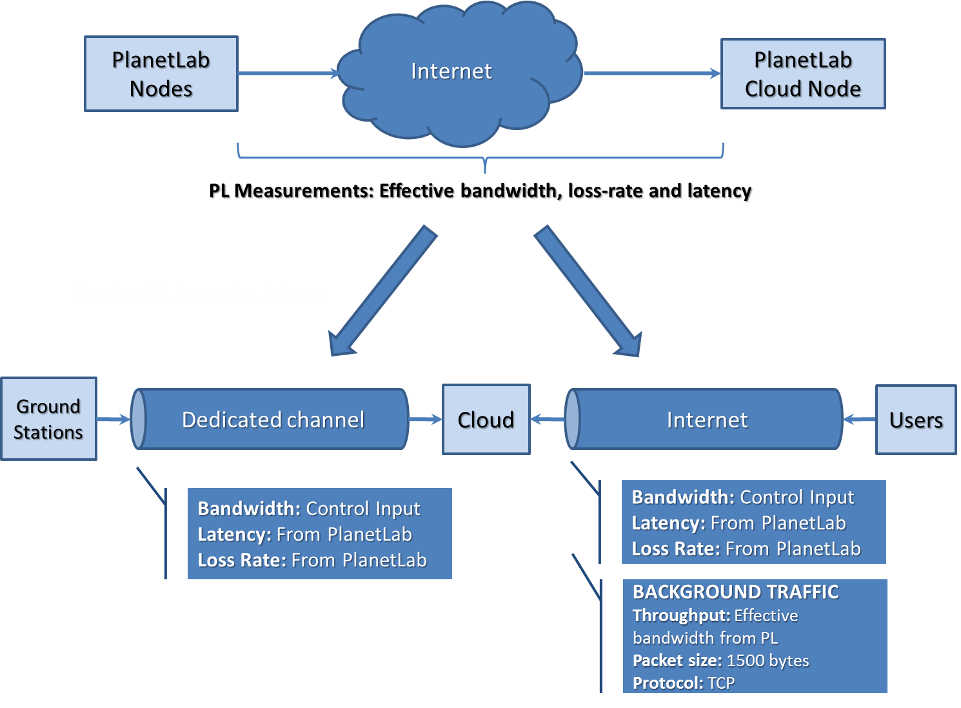
Figure 1. PlanetLab and Modelled Links Equivalences.

System modeling
The real system is modeled into three main components: i) a network of ground stations acquiring imagery data from a constellation of optical satellites, ii) a cloud infrastructure that ingests the data from the ground stations, processes it, stores it and distributes it through web services and iii) end users around the world accessing to the web services offered. The system can be divided into two layers:
- Layer 1 is constituted by 12 ground stations connecting with a cloud infrastructure. The ground stations and their location are depicted in Table 1. Their locations and footprints are depicted in Figure 2. The footprints represent the area in which the satellites can establish the communication with the ground stations.
Table 1 Ground Stations Location
Ground Station | Country of GS location
Irkutsk | Russia
Puertollano | Spain
Svalbard | Norway
Troll | Antarctic
Chetumal | Mexico
Córdoba | Argentina
Dubai | United Arab Emirates
Kourou | French Guiana
Krugersdorp | South Africa
Malaysia | Malaysia
Prince Albert | Canada

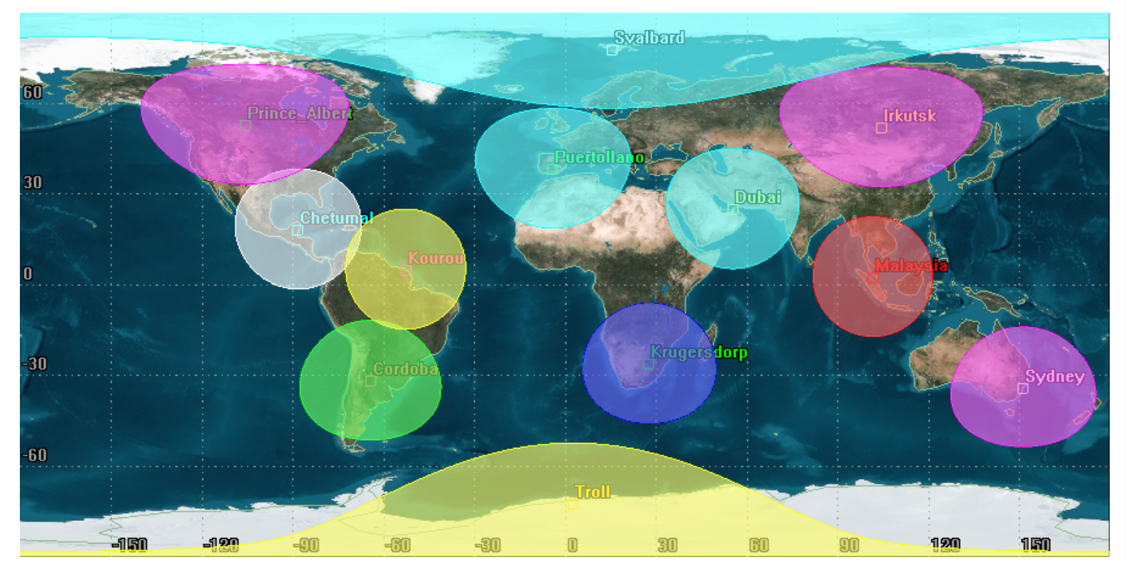
Figure 2 Footprints of the ground stations.
- Layer 2 is constituted by the end users accessing the web services implemented in cloud. These users are distributed around the world and can be governments, emergency services, media and individuals among others.
From the previous layers two networks can be identified: the network between the ground stations and the cloud and the network between the end users and the cloud. The system and the interconnections between components are depicted in Figure 3. The connections between the ground stations and end users with the cloud are represented as arrows with different line types to represent that every connection can have different characteristics and impairments. All the connections are TCP.
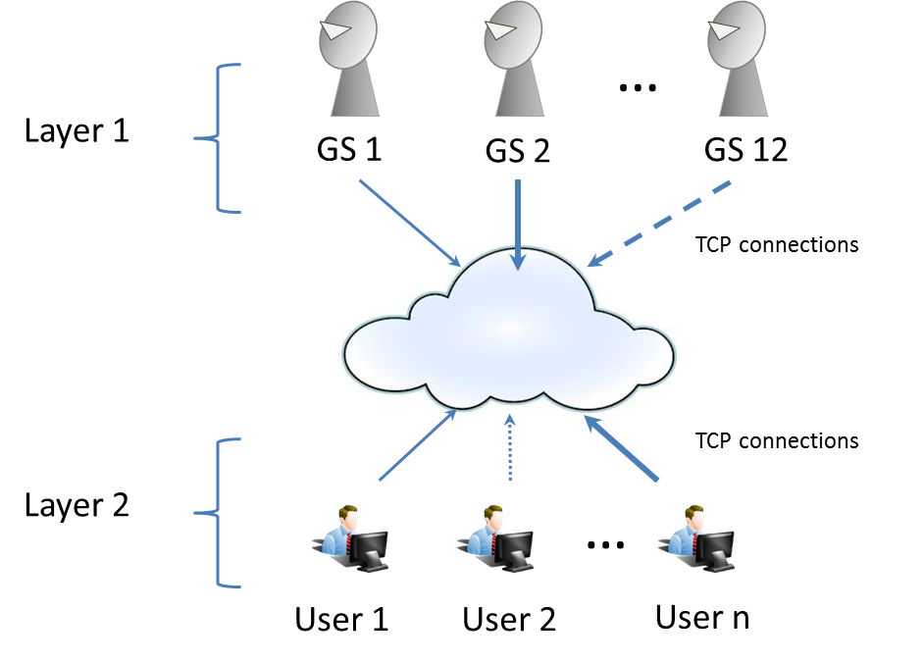
Figure 3 System description

We define the network in function of the following representative impairments: effective bandwidth, latency and loss rate. Thus, every link is represented in function of the previous impairments: effective bandwidth, latency, loss rate.
This system is implemented in Virtual Wall and BonFIRE as depicted in Figure 4. The experiment in PlanetLab will be used to update the network parameters connecting Virtual Wall and BonFIRE.
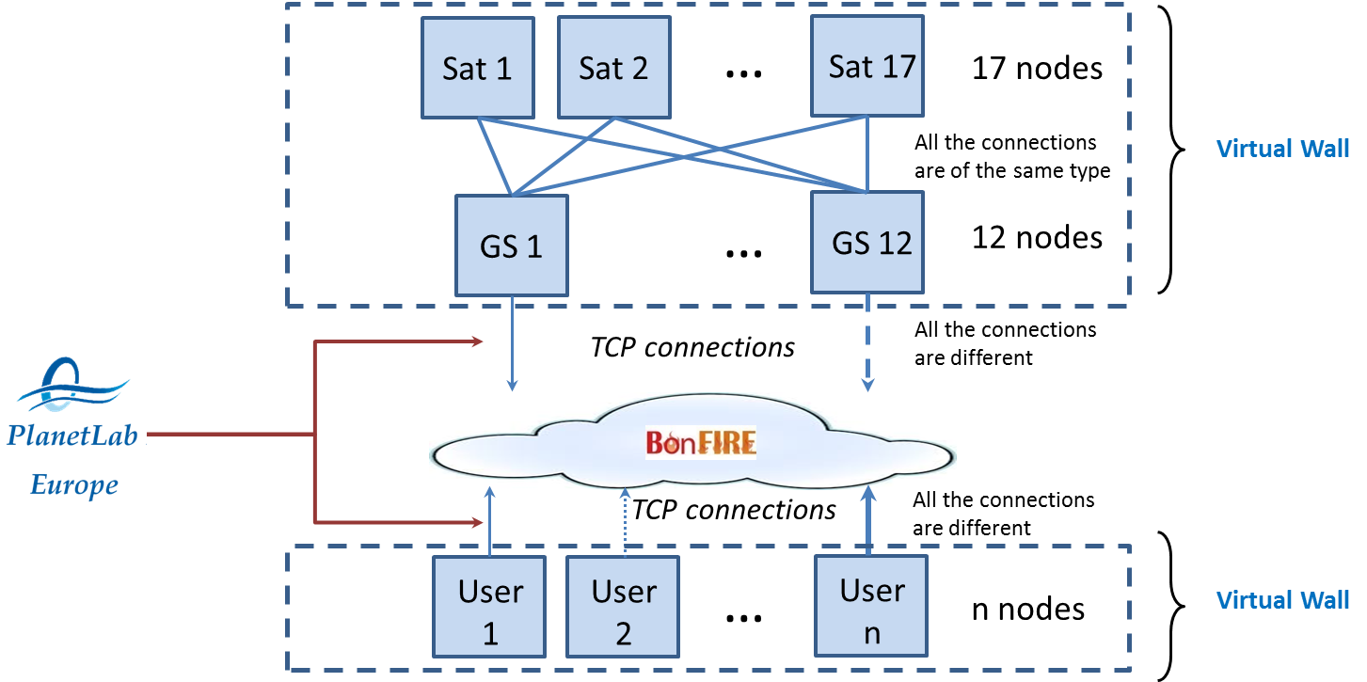
Figure 4 Scheme of the system implemented in GEO-Cloud

Network Design in PlanetLab

The model of the ground stations network, the cloud and the end users accessing the web services provided was simplified to a set of interconnected nodes. The network was divided into two layers connected by a central node representing the cloud servers for similarity with the real system:
- Layer 1: it represents the connections between 12 nodes representing the ground stations and a central node representing the cloud servers. In PlanetLab Europe and PlanetLab Central, the nearest nodes to the real location of the ground stations were selected. For the central node, a node in INRIA was chosen, since the BonFIRE cloud has servers in the same location. This layer then represents the transfer of geodata acquired by the constellation of satellites from the ground stations in which the data is downloaded to the cloud. The network topology implemented is peer-to-peer, i.e. each node representing the ground stations is directly connected with the central node. In Table 2 the PlanetLab selected nodes for layer 1 and for the cloud central node are shown. The nodes are numbered in ascending order in function of the distance to the central node, i.e. the closest node is the number 0 and the furthest the 37.
Table 2. Ground Segement Nodes.
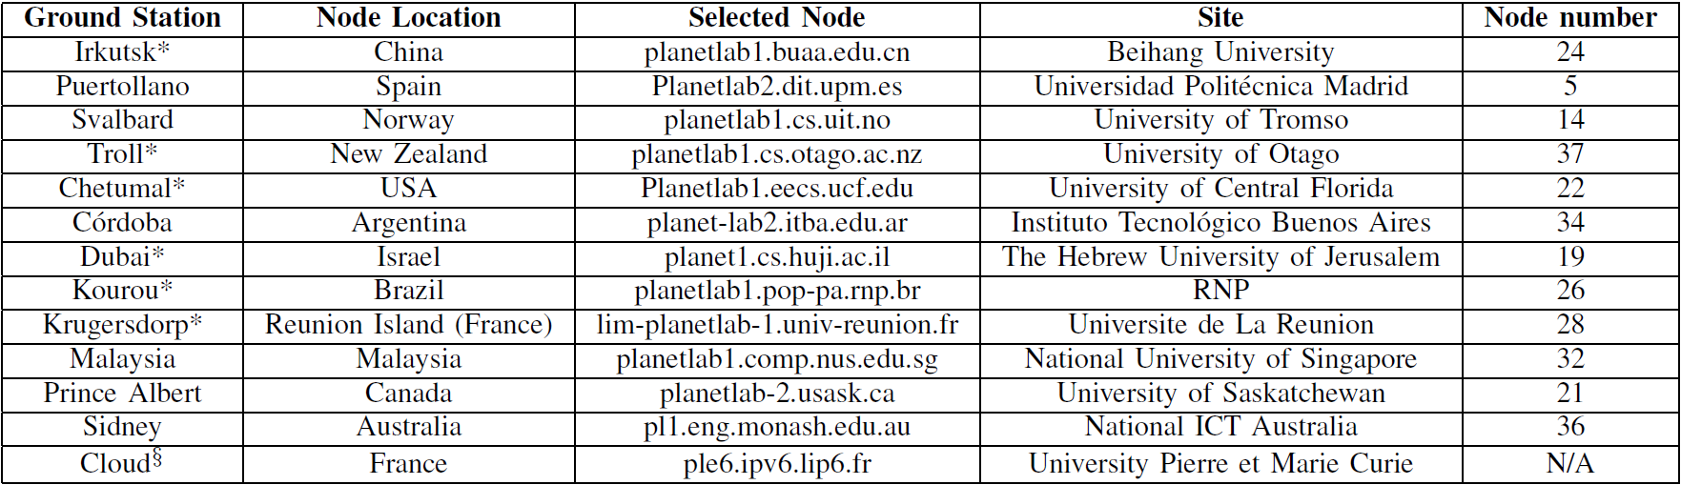
* These ground stations are located in areas without nodes, the closest node has been selected.
§ Node representing the cloud infrastructure.
- Layer 2: it represents the connection between the central node representing the cloud servers and the end users. 31 different nodes were selected in PlanetLab Europe and PlanetLab central in 31 different countries around the world. This allows us to have a representative sample of global users accessing the web services. In this case, the network topology is also peer-to-peer. In Table 3 the nodes selected for layer 2 are listed. We tried to increase the number of nodes in different countries, but during the execution of the experiment we did not find available PlanetLab nodes in the following countries: Austria, Cyprus, Denmark, Egypt, Ecuador, Iceland, India, Jordan, Mexico, Pakistan, Puerto Rico, Romania, Slovenia, Sri Lanka, Tunisia, Turkey, Venezuela, Uruguay and Taiwan.
Table 3. Users Nodes.
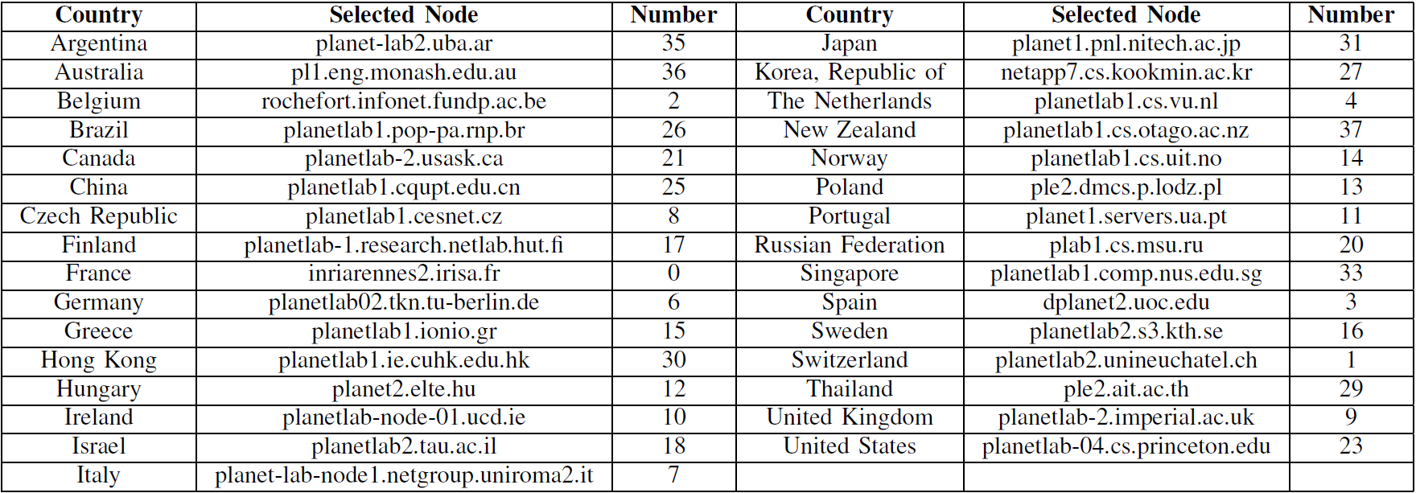
Figure 4 shows a scheme representing the network created in PlanetLab. The connections between the nodes are TCP.
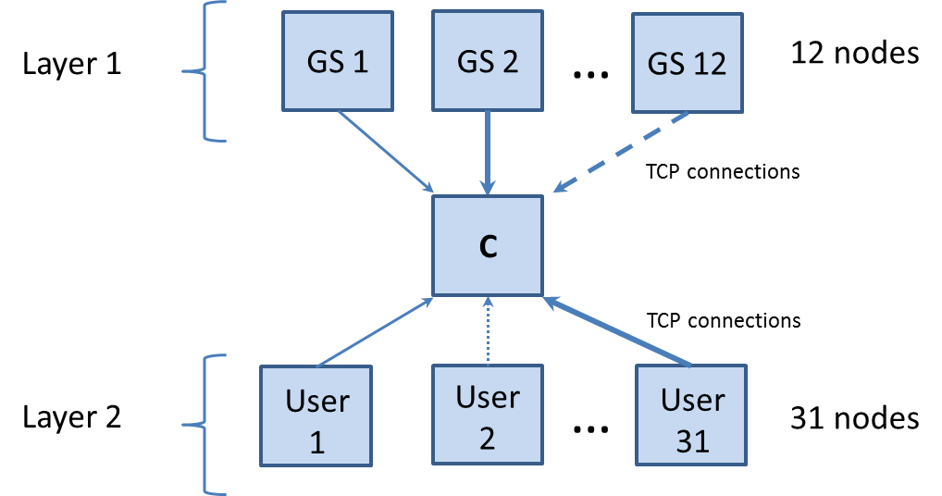
Figure 5. PlanetLab Network Scheme.

Experiment Design and execution
The experiment is designed to measure the impairments of the network. Those impairments are required parameters in Virtual Wall to deploy a topology network in such a testbed. Then, in this experiment we measured latency, loss-rate and effective bandwidth. The deployment of the experiment was done with NEPI, in which Iperf and Ping were implemented to measure the impairments. The experiment consists of establishing communications between any node in layer 1 or layer 2 with the central node and measuring the previously described impairments. 21600 trials will be done during 6 hours of the experiment execution in steps of one second for each pair of nodes, i.e. a node from layer 1 or 2 and the central node.

The software developed to measure the impairments is constituted of 6 scripts:
- Script to measure the effective bandwidth in the ground stations nodes: “bandwidthGS.py”.
- Script to measure the effective bandwidth in the end users nodes: “bandwidthEndUser.py”
- Script to measure the latency in the ground stations nodes: “latencyGS.py”.
- Script to measure the latency in the end users nodes: “latencyEndUser.py”
- Script to measure the loss rate in the ground stations nodes: “lossRateGS.py”
- Script to measure the loss rate in the end users nodes: “lossRateEndUser.py”
The pair of scripts that measure the same impairment are differentiated one from each other in the provisioning of the nodes. Those nodes representing the ground stations are manually selected, while the end users nodes are automatically provisioned by NEPI by indicating the country name as parameter. This parameter allows NEPI to select an available node in that country.

The previous six scripts are individually executed in a local host and they start their workflow.

The bandwidthGS.py script
The bandwidthGS.py script measures the effective bandwidth in the ground stations nodes. When it is executed it carries out the next tasks:
- Provisioning of the nodes that were manually selected.
- Creation of the commands to be uploaded:
  - In the cloud node
> timeout %dm iperf -s -f m -i 1 -p %d
Timeout is a command that executes a program during a specified time %dm in minutes. For this experiment dm was chosen to be 65 minutes.
-s indicates that Iperf is executed in server mode
-f m indicates the format to report the received data. In this case in Mb.
-i 1 Periodic reports every 1 second
-p %d indicates the port to listen. In our case 20004.

  - In the ground station nodes
> iperf -i 1 -f m -c %s -t %d -p %d -y c > node%d.out
-i 1 Periodic reports every 1 second.
-f m indicates the format to report the received data. In this case in Mb.
-c %s indicates the server to establish the communication with.
-t indicates the data transmission time. In our case 3600 seconds.
-p %d indicates the port to listen. In our case 20004.
-y c> node%d.out indicates that the report format is csv. The output file is node%d.out, where %d indicates the number of the node tested.
By default Iperf is executed in TCP mode.
- Uploads the commands to the nodes
- Executes the command in cloud
- Executes the command in the rest of nodes
- During the execution of the commands the data is collected
- Finishes the execution of the commands
- The data collected is retrieved
- The resources are released.
The flow diagram of the effective bandwidth measurements in the ground station nodes is depicted in Figure 6 a.

The bandwidthEndUser.py script
The bandwidthEndUser.py script measures the effective bandwidth in the end users nodes. When it is executed it carries out the next tasks:
- Automatic provisioning of the nodes.
- Tasks 2 to 9 of the bandwidthGS.py script.
The flow diagram of the effective bandwidth measurements in the end users nodes is depicted in Figure 6 b.

The lossRateGS.py script

The lossRateGS.py script measures the loss rate in the ground stations nodes. When it is executed it carries out the next tasks:
- Provisioning of the nodes that were manually selected.
- Creation of the commands to be uploaded:
  - In the cloud node
> timeout %dm iperf -s -f m -i 1 -p %d -u
Timeout is a command that executes a program during a specified time %dm in minutes. For this experiment dm was chosen to be 65 minutes.
-s indicates that Iperf is executed in server mode
-f m indicates the format to report the received data. In this case in Mb.
-i 1 Periodic reports every 1 second
-p %d indicates the port to listen. In our case 20004.
-u indicates that the Iperf software is executed in UDP mode.
  - In the ground station nodes
> Iperf -i 1 -f m -c %s -t %d -p %d -u -y c > node%d.out "
-i 1 Periodic reports every 1 second
-f m indicates the format to report the received data. In this case in Mb.
-c %s indicates the server to establish the communication with.
-t indicates the data transmission time. In our case 3600 seconds.
-p %d indicates the port to listen. In our case 20004.
-y c> node%d.out indicates that the report format is csv. The output file is node%d.out, where %d indicates the number of the node tested.
-u indicates that the Iperf software is executed in UDP mode.

- Uploads the commands to the nodes
- Executes the command in cloud
- Executes the command in the rest of nodes
- During the execution of the commands the data is collected
- Finishes the execution of the commands
- The data collected is retrieved
- The resources are released.
The flow diagram of the loss rate measurements in the ground station nodes is depicted in Figure 6 a.

The lossRateEndUser.py script
The lossRateEndUser.py script measures the loss rate in the end users nodes. When it is executed it carries out the next tasks:
- Automatic provisioning of the nodes.
- Tasks 2 to 9 of the lossRateGS.py script.
The flow diagram of the loss rate measurements in the end users nodes is depicted in Figure 6 b.

The latencyGS.py script
The latencyGS.py script measures the latency in the ground stations nodes. When it is executed it carries out the next tasks:
- Provisioning of the nodes that were manually selected.
- Creation of the commands to be uploaded:
>ping %s -w %d
%s indicates the host to do ping
-w %d indicates the time of the ping execution.
- Uploads the commands to the nodes
- Executes the command in cloud
- Executes the command in the rest of nodes
- During the execution of the commands the data is collected
- Finishes the execution of the commands
- The data collected is retrieved
- The resources are released.
The flow diagram of the latency measurements in the ground station nodes is depicted in Figure 7 a.

The latencyEndUser.py script

The latencyEndUser.py script measures the loss rate in the end users nodes. When it is executed it carries out the next tasks:
- Automatic provisioning of the nodes.
- Tasks 2 to 9 of the latencyGS.py script.

The flow diagram of the latency measurements in the end users nodes is depicted in Figure 7 b.
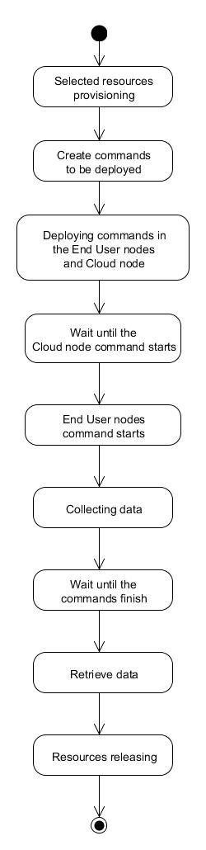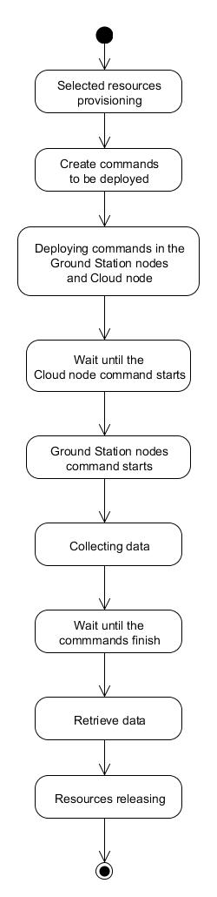
(a)
(b)
Figure 6 Workflow of the bandwidth and loss rate measurement. (a) Workflow in the end users nodes. (b) Workflow in the ground stations nodes.

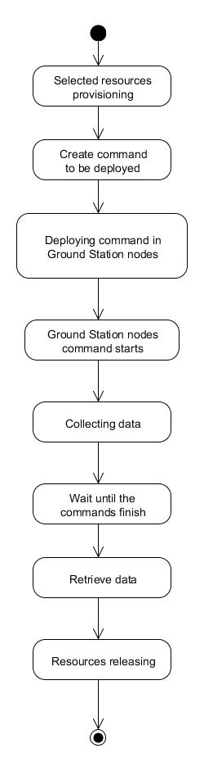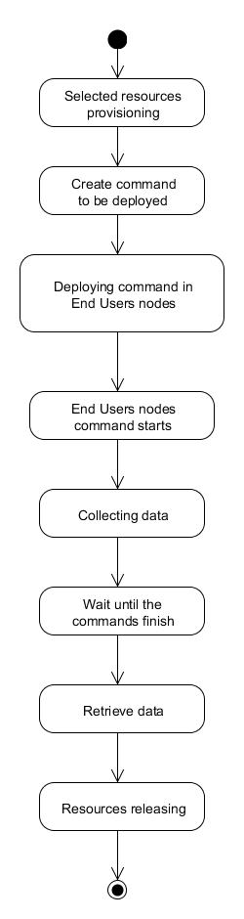
(a)
(b)
Figure 7 Workflow of the latency measurements. (a) Workflow in the end users. (b) Workflow in the ground stations nodes.

Conclusions
In this document the part of the GEO-Cloud experiment executed in PlanetLab is presented. Topology networks have been created in two layers to simulate the communications between the ground stations and the cloud infrastructure and between such a cloud infrastructure with end users around the world accessing web services computed in cloud. The experiment consists of measuring the real network impairments (effective bandwidth, latency and loss rate) to obtain an approach for its later implementation in the complete Earth Observation system simulator implemented in Virtual Wall and BonFIRE.

Bibliography
Europe, P. (2014). PlanetLab Europe Project. PlanetLab Europe Project. Retrieved from http://www.planet-lab.eu/
INRIA. (2014). NEPI. NEPI. Retrieved from http://nepi.inria.fr/
Iperf. (2014). Iperf. Iperf. Retrieved from http://iperf.fr/
Pelsser, C., Cittadini, L., Vissicchio, S., & Bush, R. (2013). From Paris to Tokyo: On the Suitability of ping to Measure Latency. Proceedings of the 2013 conference on Internet measurement conference, (pp. 427-432). Retrieved from http://conferences.sigcomm.org/imc/2013/papers/imc125s-pelsserA.pdf

